Contents
1 Database and DBMS design 2
1.1 Database Requirements 2
1.1.1 Scenario 2
1.1.2 Data Requirements 2
1.1.3 User and system requirements 2
1.2 Database Design 2
1.2.1 Conceptual model 2
1.2.2 Model mapping and logical design 2
1.2.3 Physical model 2
1.3 DBMS Architecture and Programming Techniques 3
1.4 Data Transfer 3
1.4.1 Flowchart and DFD 3
1.4.2 Evaluation of data transfer 3
1.5 Effectiveness of the database and DBMS 3
2 DBMS Development 3
2.1 SQL Queries 3
2.2 Data structures 3
2.3 Indexing 3
2.4 Criticizing the mapping of SQL queries 4
3 Concurrency Control (CC) 4
3.1 Standard DBMS CC Techniques 4
3.2 Implementation of CC 4
4 User Interface and Testing Plan 4
4.1 User Interface Development 4
4.2 Testing Plan 4
4.3 Evaluation 4
References 4

Database and DBMS design

Database Requirements

Scenario
The suggested database system will be a Gate Access and Vehicle Authorization System that will control vehicles entering a secure area consisting of several zones and gates. Security personnel (or an automatic gate application) use the system to determine whether a particular vehicle should be permitted to enter a gate and to document the result of an attempt.

The database captures the following real-life entities:
- Organizations (HTU, companies, service providers).
- Roles (Student, Staff, Security, Visitor)
- Members of an organization who are in a position.
- Vehicles registered to a user and allocated to a zone.
- Areas denote areas within the facility (parking areas, buildings, restricted areas).
- Gates that are physical entry points which can be enabled/disabled.
- gate-Zone mapping explaining what gates get to which zones.
- Rules of allow/deny permissions per gate of either roles or specific vehicles.
- Access Logs Which are lists of all the attempts to access the gate (allowed/denied) with a time stamp and reason.

The designed DBMS has a menu-based interface that executes CRUD operations on every table and ensures that operations act as SQL:
- Insert will be rejected in case of the existence of the primary key (duplicate PK).
- Any attempt to insert/ Update will be rejected when any of the necessary foreign keys does not exist.
- Deletion is not allowed in case the record is used in other tables (SQL "RESTRICT" behaviour).
- Access attempts are handled with stored data of gate/zone/ permission and the outcome is recorded in a log record.
- In real life, the system verifies that:
- the car is present and it is associated with a legitimate user
- the gate is there and it is turned on
- the gate is allocated to the vehicle area
- Rules (where there are any) are denied and followed by allow rules.
- the final decision (ALLOWED/DENIED) is logged in the access log with a definitive reason.

Data Requirements
- The system is meant to control the access to a secure facility comprising of various areas and controlled by several physical entrance control points.
- The facility has various areas that include parking areas, buildings and restricted areas. The name and description of each zone are clear to easily identify and understand.
- Gates are physical access points of the facility. Each gate has a name, location as well as the operational status, enabling or disabling when necessary.
- All gates are connected to certain zones such that only vehicles can access gates that suit the zone that they are supposed to serve. This helps to avoid the unauthorized access to wrong areas.
- Organisations like universities, partner companies or service providers are registered in the system. These groups are the institutions in which the members are permitted to access the facility.
- The registered members of the system are members of a single organization. There is basic personal data, such as name, contacts and the current activity of the individual.
- Each person has a specific role (as a student, staff member, security personnel or visitor). This position is significant in the process of setting the access rights of the individual.
- People can own either cars or multiple cars. Vehicles are registered and their details that include plate number, manufacturer, model, color and operational status are registered.
- Any vehicle is associated with a good owner and a particular zone in the facility. This will make sure that cars are never linked to an unauthorized user and a wrong location.
- Access rules determine the entry through a gate to be permitted or not. Such regulations may be imposed on a particular vehicle or on a certain group of people according to their position.
- There can be several rules on each gate. In the case that a rule has an explicit denial, it is followed. Only allow rules will be considered in case there is no denial rule. In case there is no rule to grant access, default denies entry.
- Any access is logged in an access log. Every log entry contains the time that the attempt was made, the gate through which it was attempted, the vehicle the person concerned, the decision made and an explicit reason on why the decision was reached.
The system imposes strict rules of consistency just like a real database:
- Records should possess distinctive identifiers.
- It is impossible to refer to something that does not exist.
- Records that have still records in use cannot be deleted.
- Decision to access is arrived at after checking the vehicle, owner, gate status, the zone compatibility and the rules.
- This is such a structure that the access is controlled securely, records are kept correctly and all entry attempts are fully traceable to facilitate auditing and security needs.

User and system requirements
User groups
- System Operator (DBMS Operator)
  - Has access to complete power over the data in the system.
  - In charge of record keeping, ensuring that records are accurate, and auditing.
- Security Personnel (Gate Operator)
  - Utilizes the system to determine whether a vehicle goes through a certain gate or not.
  - Needs to get a glimpse of the decision and the reasoning fast, and make sure all efforts are documented
- Gate Applicant / Automatic Gate Controller.
  - The system rules are used to make an automatic allow/ deny decision.
  - Require quick access to status of the gates, mapping zone-gates and permission.
- Organization Management (HTU / Company Admin)
  - Administrative needs Reports or lists of their members and vehicles.
  - Ensures that the information about the members and vehicles is correct and current.
- Facility Member (Student / Staff / Visitor / Service Provider)
  - Not a direct user of the system (is not its operator).
  - Their vehicles and access rights should be properly registered to ensure that they are not wrongly denied.
How each user interacts with the system and their needs
System Administrator: Makes inserts, updates, deletes, searches and lists data in all the tables.
Needs full visibility of:
- Organizations, roles, users
- Zones and gates
- Gate-zone connections
- Vehicles
- Allow/deny permission rules
- Access logs
- Requires the system to reject invalid operations just as a real database (duplicate IDs, missing references, limited deletes).
Security Personnel: Checks the gate access by choosing a vehicle and a gate.
Needs:
- A definite ruling (ALLOWED / DENIED).
- A obvious explanation (e.g. gate disabled, no permission, zone mismatch).
- Confirmation that the attempt is audited.
Automatic Gate Controller: The same logic of access check is done automatically.
Needs:
- Checked rules (rules that have been denied are subject to checking).
- Enforce gate enables properly.
- Fidelity and record keeping.

Organization Management: Views provide lists of cars and users within their organization.
Needs:
- Correct membership/ vehicle ownership details.
- Capacity of determining idle users or invalid vehicle assignments.
Facility Member: Not an interface user, is influenced by the data stored.
Needs:
- Proper registration (owner, zone, role).
- Decisions of fair access based on stored rules.

Desirable system requirements (system-side)
Web-based administrative control.
- An interface in the form of a menu that will enable the administrator to view all the tables and can do complete CRUD operations.
Database-like integrity rules
- The unique identifier of a record must not be inserted again.
- When a record has a reference to missing information (user must be a member of an existing organization and role) it should not be inserted or updated.
- Block deletion of a record in case it is still used by other records (restricted delete behaviour)
Dependable access determination logic.
- Check the existence of the vehicle and its connection with a legitimate user.
- Make sure that the gate is present and turned on.
- Check that the gate is geared towards the zone of the vehicle.
- Rules should be applied in the right sequence:
  - Deny rules first
  - Allow rules second
  - If none match - deny by default
Record the final decision and reason into the access log.
Auditability
- All access attempts should be traced using:
  - Date/time
  - vehicle, gate, user
  - outcome
  - reason
Persistent storage
- Information must be stored and reloaded (csv files) to maintain the system state over time.

Database Design

Conceptual model

What is the Conceptual Design?
The conceptual designed is a high level description of the database system that aims at stating what data should be stored and how various sections of the system are interconnected without regard to the physical storage of the data or how the data will be coded.
At this point, the design has no relation with any programming language or database software. It presents the system in a real-life view and hence easy to comprehend by both the technical and non-technical stakeholders.

Goal of the Conceptual Design
The overall purpose of the concept design is to:
- Distinguish the key elements of the system.
- Demonstrate the interrelationship of these parts.
- Make sure that all data requirements of the system are taken properly.
- Form a strong background to the subsequent steps like logical and physical database design.
In the case of the Gate Access and Vehicle Authorization System, the conceptual design makes sure that the access decisions, ownership, permissions and logging are all well represented in a clear and consistent manner.

Components of the Conceptual Design.
The conceptual design will comprise of:

- The key components of the system that is used to regulate the access of the gates.
- The relations of people, cars, gates, areas, and authorizations.
- The policies that define the way the access decisions are determined.
- Auditing and security the capturing of access attempts.
A conceptual diagram is used to visualize these elements and this gives a clear picture of the structure of the system.

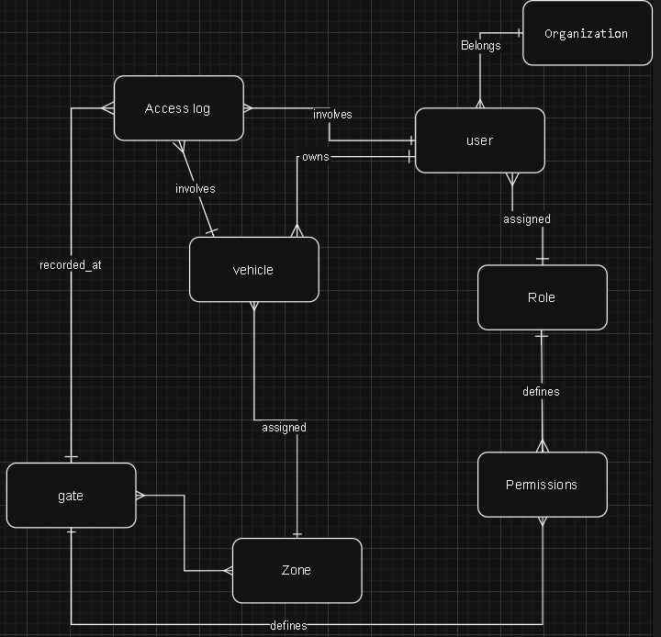
Conceptual Design Figure Brief Description.
The figure shows how the system will deal with the access to a secure facility:
- People are part of a given organization, and they are assigned a particular position which could be a student, staff or visitor.
- Every person can have one or several vehicles.
- Each of the vehicles is related to a particular area within the facility.
- The facility is subdivided into areas, and the areas are reached through one or more gates.
- Gates are physical points of entry and are linked to areas to regulate access points of vehicles
- The permissions will either permit or deny access to a particular gate by a group of users (via a role) or a particular vehicle.
- An access log is formed when a vehicle tries to pass through a gate.
- Access log contains the name of the gate, the vehicle, the user, the time the attempt was made, the decision made and the cause of the decision.
This diagram gives a clear and single picture of how the decision of access control is made and all the efforts are traced to secure and audit them.

Model mapping and logical design
What the logical design is
The logical design explains the database in detail (tables and columns) and indicates how the tables are related to one another using keys, but not how the database is implemented (in terms of file layout or storage structures). It is the next step to conceptual design, in which the relationships are translated into the relational tables and the many-to-many relationships are solved with the help of an extra table.
Database Schema (After Mapping)
1) Organization
- Organization(OrgID PK, OrgName, OrgType)
2) Roles
- Roles(role_id PK, name, description)
3) Users
- Users(user_id PK, FirstName, LastName, email, Phone, status,
OrgID FK → Organization(OrgID),
role_id FK → Roles(role_id))
4) Zone
- Zone(ZoneID PK, ZoneName, description)
5) Gates
- Gates(gate_id PK, name, enabled, location)
6) Gate_Zone (resolves M:N between Gates and Zone)
- Gate_Zone(ZoneID PK/FK → Zone(ZoneID), gate_id PK/FK → Gates(gate_id))
7) Vehicles
- Vehicles(vehicle_id PK, license_plate, make, model, color, status,
ZoneID FK → Zone(ZoneID),
user_id FK → Users(user_id))
8) Permissions
- Permissions(permission_id PK, target_type, target_id, action, created_by,
gate_id FK → Gates(gate_id),
role_id FK → Roles(role_id))
9) Access_Log
- Access_Log(log_id PK, timestamp, outcome, reason,
gate_id FK → Gates(gate_id),
vehicle_id FK → Vehicles(vehicle_id),
user_id FK → Users(user_id))
Logical design diagram
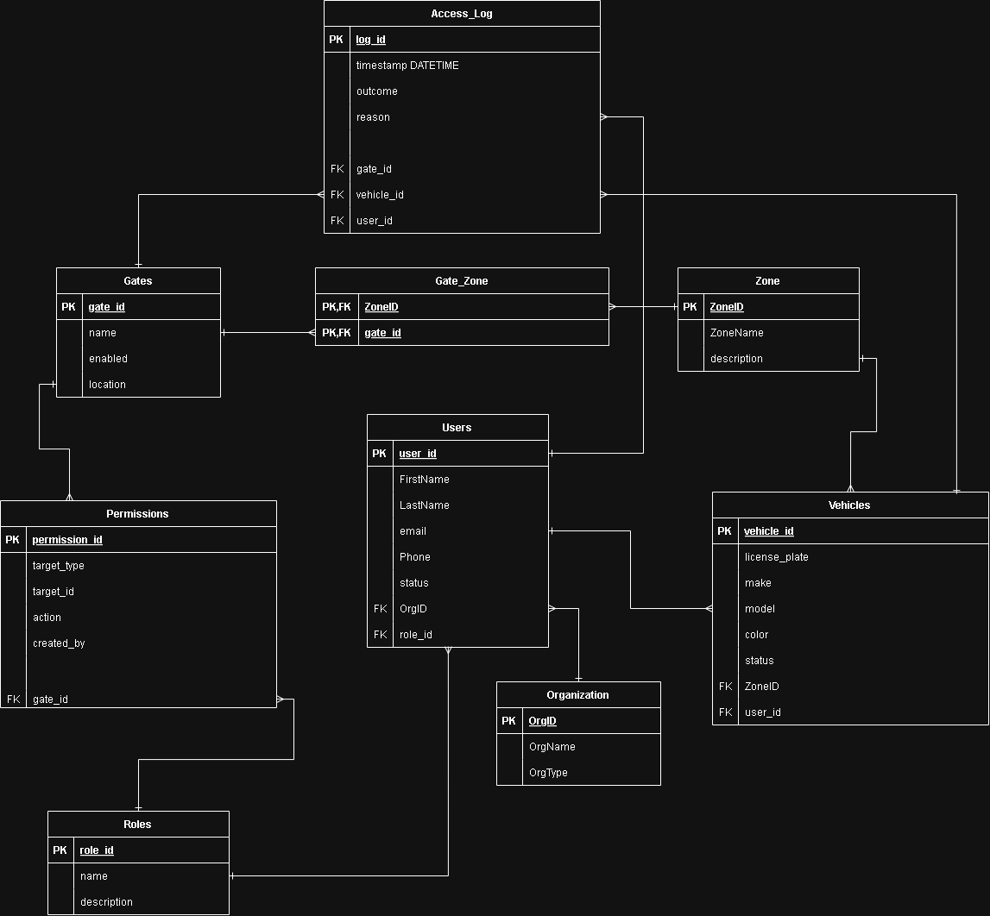
Brief Description
- The diagram depicts the manner in which the system will store people and their respective organizations/roles, vehicles and respective zones and gates that lead to zones.
- The Gate Zone table is created because of the many to many relationships between the gates and the zones (a zone may have numerous gates, and a gate may serve numerous zones).
- Gates have permission/deny rules, and a rule can be directed at either:
  - a role
  - a specific vehicle.
- Every attempt to access the gate is logged in the Access Log with a timestamp, result, cause and the references to the gate, vehicle and user which means that the system can be audited.

Physical model

What the physical design is
The physical design gives an account of how the database will be implemented within a real DBMS and this is in terms of the actual tables, column data types, constraints (NOTNULL, Unique, CHECK) and key relationships. The physical design unlike the conceptual and logical design is concrete and implementable since it outlines the actual structure that will be established in SQL.

Goal of the physical design
The goal of the physical design is to:
- Transform the logical model into actual database tables comprising of actual data types and constraints.
- Assure data integrity, that is, the database does not allow invalid data (duplicate IDs, missing references, invalid values) in the database.
- Facilitate the primary operations of the system which includes:
  - Registering vehicles/users
  - Defining gate-zone mappings
  - Storing allow/deny rules
  - Auditing access attempts (auditing).
Components of the physical design
The physical design contains:
- Real SQL data types of tables and column (VARCHAR, DATETIME, BOOLEAN).
- Primary keys (PK) to ensure that records are unique.
- Foreign keys (FK) to enforce valid references between tables
- Constraints such as:
  - NOT NULL to make sure that the mandatory fields are present all the time.
  - UNIQUE not to create duplicates when needed (license plate, organization name
  - CHECK to limit values (permission targets and decisions)
Physical Design Diagram
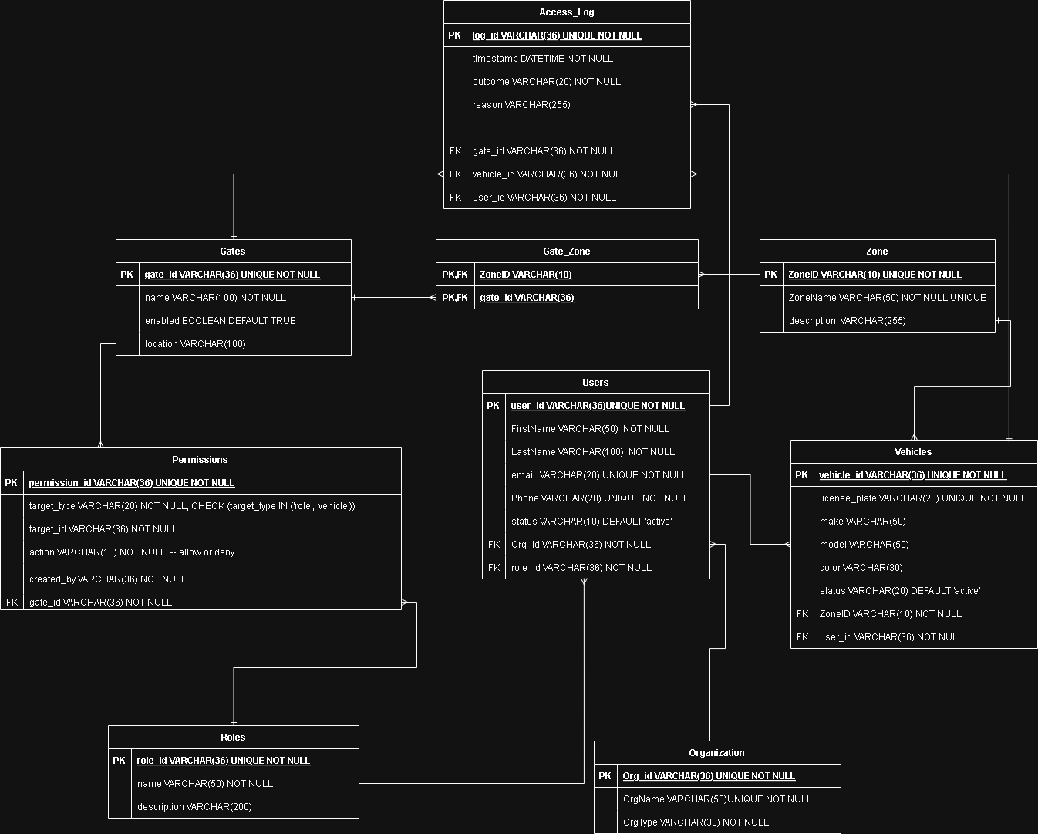
Brief description of the physical design figure
The diagram shows a secure facility access-control database where:
- Users are the members of an organization and they have a role.
- Vehicle are owned by users and allocated zones.
- The gates are linked to zones via the Gate Zone table.
- Permission allows/denies apply to each gate and are specified against either a role or a vehicle.
- Access Log captures all entry attempts that include a timestamp, decision and reason that are associated with gate, vehicle and user.

Table | Name | Description
 | Organization | This table is used to store the organizations which work in the facility like HTU, companies which are partners or service providers.  The organizations are identified by a unique identifier known as Orgid ( VARCHAR (36), NOT NULL, UNIQUE ) to make sure that there are no two organizations with the same identifier.  The duplication of the organization names is avoided by the field, OrgName (VARCHAR(50), NOT NULL, UNIQUE) so that the organization name appears only once.  The organization (e.g. educational, company, or service provider) is defined by the field of OrgType ( VARCHAR(30), NOT NULL).  The key of this table is the primary key that is Orgid and it has no foreign key.
 | Roles | This table will specify the various category of roles that will be used to regulate access in the system which include, Student, staff, security, and visitor.  The roles are uniquely defined using roleid ( VARCHAR(36), NOT NULL, UNIQUE).  Role label is stored in the name (VARCHAR(50), NOT NULL) field and description ( VARCHAR(200)) field gives further elaboration concerning the position.  The roleid is the primary key and this table does not have any foreign keys.
 | Users | This table contains the data of the registered members using the facility and can have vehicles.  Userid ( VARCHAR(36), NOT NULL, UNIQUE) is used to identify each user uniquely.  The basic identification information is stored with the help of FirstName ( VARCHAR(50), NOT NULL) and LastName ( VARCHAR(100), NOT NULL).  The email (VARCHAR(20), NOTNULL, UNIQUE) field is used to make sure that there are no two users who have the same email address.  Two fields are used in the design of the system, namely, the Phone ( VARCHAR(20), NOT NULL, UNIQUE) to save a unique phone number of each user.  The status ( VARCHAR(11), DEFAULT active) column enables one to activate or deactivate the user without deleting his records.  The primary key is userid.  Orgid - Organization(Orgid) and roleid - Roles(roleid) are used as foreign keys so as to guarantee that every user is of a valid organization and such a user must have a valid role to access.
 | Zone | This table contains the various zones or areas in the facility, which could be a parking area, building or restricted areas.  ZoneID ( VARCHAR(10), NOT NULL, UNIQUE) is used as a short code to identify each zone.  The ZoneName ( VARCHAR(50), NOT NULL, UNIQUE ) is used to ensure that there are no duplicate names of the zones and description ( VARCHAR(255)) is used to give more information about the area.  ZoneID is the primary key and the foreign keys are nonexistent.
 | Gate | This table will be an expression of the physical gates or entry points of the facility.  The gates are uniquely identified by gateid ( VARCHAR (36) not null, unique).  The label of the gate is stored in the name (VARCHAR(100), NOT NULL) field and the location of the gate is written in the location (VARCHAR(100)) field.  The enabled (BOOLEAN, DEFAULT TRUE) field is used to tell whether the gate is operational or not.  The gateid is the primary key and this table does not have any foreign keys.
 | Gate_Zone | This table eliminates the many-to-many relationship between gates and zones as one gate can serve many zones and one zone can be served by many gates.  One gate-zone connection is represented in each of the records withZoneID (VARCHAR(10)) and gateid (VARCHAR(36)) as a pair.  The composite primary key (ZoneID, gateid) avoids the duplicate mappings.  Foreign keys ZoneID- Zone(ZoneID) and gateid - Gates(gateid) make sure that only existing zones and gates are allowed to be connected.
 | Vehicles | This table contains vehicles which are authorized to enter the facility and the vehicles are associated with their owners and designated zones.  The vehicleid (VEHICLEID) is a unique identifier of each vehicle ( VARCHAR(36), NOT NULL, UNIQUE).  The licenseplate ( VARCHAR(20) NOT NULL, UNIQUE) field prevents the occurrence of a vehicle which has the same license plate as another one.  Other details of identification are stored in make (VARCHAR(50)), model (VARCHAR(50)) and color (VARCHAR(30)).  The status ( VARCHAR(20) DEFAULT active) enables the cars to be recorded as inactive or blocked without deleting their records.  The primary key is vehicleid.  ZoneID -Zone(ZoneID) is a foreign key to identify the existence of a legitimate zone to which the vehicle belongs and userid -Users(userid) to identify the existence of the legitimate registered owner of the vehicle.
 | Permissions | This table holds authorization regulations which authorizes or deny access to a gate.  Permissionid (VARCHAR(36), NOT NULL, UNIQUE) is unique identifier of each rule.  The field of targettype ( VARCHAR(20) not null which has a CHECK constraint limiting the values to either role or vehicle ) indicates whether the rule is applicable to a role or a particular vehicle.  Targetid ( VARCHAR(36), NOT NULL) is the targetid that holds the corresponding roleid or vehicleid based on the type of target.  The decision (allow or deny) is stored in the action ( VARCHAR(10) field, which is not null).  The createdby (VARCHAR(36) field is a field that documents the person who created the rule as a traceability.  The gateid (VARCHAR(36) is a non-key connecting the rule to a particular gate.  Permissionid is the primary key and the gateid - Gates(gateid) is used to ensure that only valid gates are used up.
 | Access_Log | This table has a full audit trail of all attempts to access the gate with or without authorization.  The logs are uniquely identified by logid ( VARCHAR(36) NOT NULL, UNIQUE).  The timestamp (DATETIME, NOT NULL) is used to note the time when the access attempt got performed.  Final decision (whichever is ALLOWED or DENIED) is saved in the outcome ( VARCHAR(20) but is not a key.  The reason ( VARCHAR(255)) field gives a clear explanation of the decision that is easily understood by humans.  The primary key is logid.  There are foreign keys gateid - Gates(gateid), vehicleid - Vehicles(vehicleid) and userid - Users(user_id) to make sure that every log record will be referenced to the existing records and will be fully audited.

DBMS Architecture and Programming Techniques

DBMS Architecture Overview
The architecture of the DBMS consists of the following main components:
- User Interface Layer (CLI Layer)
- Application Logic Layer
- Data Management Layer
- Indexing Layer
- Persistence Layer (File Storage)
- Logging and Auditing Component
Each component is implemented explicitly in code and interacts with the others in a controlled manner.
User Interface Layer (Command-Line Interface)
Purpose
This layer gives communication between the user and the DBMS.
Implementation
- Handed over with a menu-based command-line interface.
- Functions such as:
  - showtablemenu()
  - showopsmenu()
  - tableoperationsmenu()
- User input is collected using helper functions:
- readint()
- readstr()

Programming Techniques Used
- Procedural programming
- Input validation
- Loop-based menu navigation
Why this design was chosen
- Simple, portable, and suitable for C
- Clear separation between user interaction and internal logic
- Easy to extend with additional tables or operations

Application Logic Layer
Purpose
This layer applies business rule and constraints and access control logic.
Examples
- Check of foreign key (check user is a member of a valid organization).
- Gate access decision logic
- Denying the rule(s) above the ALLOW rules (rule precedence)
Key Function
int registergateentry()
This function:
- Authenticates the vehicle, user, gate and zone.
- Applies permission rules
- Honors access (ALLOWED or DENIED).
- Records all attempts of access.
Programming Techniques Used
- Conditional logic
- Rule-based decision making
- Sequential validation
- Fail-first (early fail) plan.
Why this design was chosen
- It resembles real-life access control systems.
- Has a good enforcement of rules.
- The complex logic is concentrated.

Data Management Layer
Purpose
Administers the in-memory representation of records and tables.
Data Structures Used
- Table storage using Linked Lists.
- Each table has:
  - A node structure (UserNode)
  - A table controller (UserTable)
Why Linked Lists Were Used
- Dynamic size (no predefined limit)
- Effective insertion and deletions.
- Applicable to file loaded datasets.
Operations Supported
- Insert
- Update
- Delete
- Traverse
- List all records

Indexing Layer (Hash-Based Indexes)
Purpose
Presented are quick access to records through primary keys.
Data Structures Used
- Hash tables designed, based on arrays.
- Linear probing Open addressing.
- The entries to be deleted safely are dummy (tombstone) entries.
Each index has:
key: the table’s primary key value
ptr: a pointer directly to the record in memory
Hash Function
int indexHashCode(int key) {
if (key < 0) key = -key;
return key % INDEXSIZE;
}

Collision Handling
- Linear probing
- Null values are simulated by dummy entries.
Index Rebuilding
void buildallindexes()
This function:
- Clears all existing indexes
- follows through the linked list of each table.
- Inserts key-pair in hash tables once more.
Why Hash Indexes Were Used
- Minimize the average performance of O(n) to O(1).
- Enhance the performance of frequent look up operations.
- Fake DBMS indexing interfaces.

Persistence Layer (File-Based Storage)
Purpose
Ensures data persistence between program executions.
Implementation
- The tables are stored in CSV files each.
- Functions include:
  - Write_users(), read_users()
  - Write_vehicles(), read_vehicles()
Techniques Used
- uniform file input/output (fopen, fprintf, fscanf)
- Header-based CSV parsing
- Sequential file scanning
Why CSV Files Were Used
- Simple and human-readable
- Easy debugging and testing
- requires no external libraries.
- Appropriate in the implementation of DBMS in education.

Logging and Auditing Component.
Purpose
Logs all the database and access requests.
What is Logged
- Inserts
- Updates
- Deletes
- Access attempts
- Old and new values
- Timestamp
- Username
Programming Techniques Used
- Append-only logging
- Timestamp generation
- Audit trail design
Why Logging Was Included
- Simulates real DBMS auditing
- Enhances accountability
- Permits tracking of operations.
Component | Technique Used
Table Storage | Linked Lists
Fast Lookup | Hash Tables
Collision Handling | Linear Probing
Persistence | CSV File I/O
Control Flow | Menu-driven CLI
Integrity Enforcement | Manual FK checks
Auditing | Write-ahead style logging
Memory Management | Dynamic allocation (malloc/free)

Final Architectural Justification.
The selected DBMS architecture ensures a trade-off between simplicity, performance and correctness.
Linked lists can be used to have flexibility in storage, hash index is used to guarantee efficiency in the retrieval, CSV can be used to store the information, and logging can be used to ensure that it is traceable. This modular design permits the development, testing, and reasoning about of each component separately, which is more like the internal architecture of actual database systems and is educational where the implementation can be done in C.

Data Transfer

Flowchart and DFD
Data Flow Diagrams (DFD)
The Data Flow Diagrams helped research and assess the capability of the DBMS to exchange data among its internal structures. The data flow charts show the flow of the data provided by the user interface to the system layers and eventually to the persistent storage.

DFD Level 0 (Context Diagram)
Level 0 DFD shows a high level perspective of the system. It displays the User/Operator communicating with the DBMS by typing commands in the command line like insert, update, delete, search, list operations and gate entry requests. These inputs are processed by the DBMS which gives the user the results of the operations.
It is also indicated in the diagram that the DBMS reads and writes to CSV files, which constitute the persistent storage of all the tables, and audit information to the dblog.csv file. This diagram affirms that the system supports bidirectional data flow between the user, the DBMS, and other external data stores.
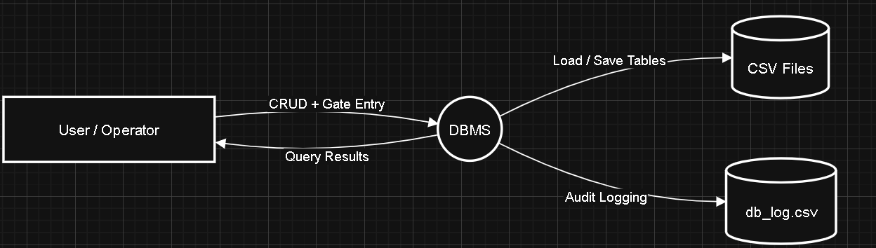

DFD Level 1 (Interaction between Internal Components)

The Level 1 DFD breaks down the DBMS into its key internal elements to show the finer movement of data. The Menu and Input Handler receive and process user inputs and send them to the Operations and Rules component, where business rules and validation are executed.
Validated data is moved to In-Memory Tables which is implemented on linked lists and fast access is facilitated by Indexing Manager which is based on hash-based indexes.
The Persistence Manager will load data in CSV files into memory on startup and will save updated data on CSV files on exit. Simultaneously, the Audit Logger logs any modifications of data by writing detailed change logs to dblog.csv.
This diagram indicates that this system can ensure that data is moved in the right direction between logical layers and separation of concerns.
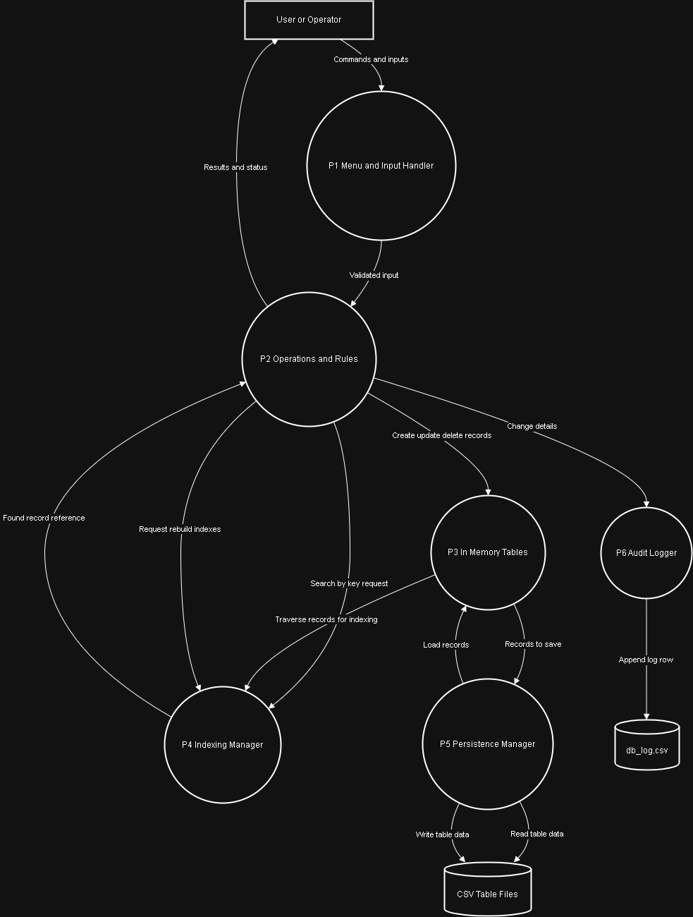

DFD Level 2 (Gate Entry Process)

The key system operations that the Level 2 DFD is concerned with are the operation of a Gate Entry. It depicts the flow of vehicle and gate identifiers among several elements, which are Vehicles, Users, Gates, GateZone, and Permissions tables.
With the input of these, the system reviews the access rules and produces an access decision (ALLOWED or DENIED). The output is stored in the table of Access Log and subsequently saved to accesslog.csv and an audit record is created in dblog.csv.
This diagram illustrates intricate data flow in and out using several tables and how the system combines validation, decision making, and logging within one operation.
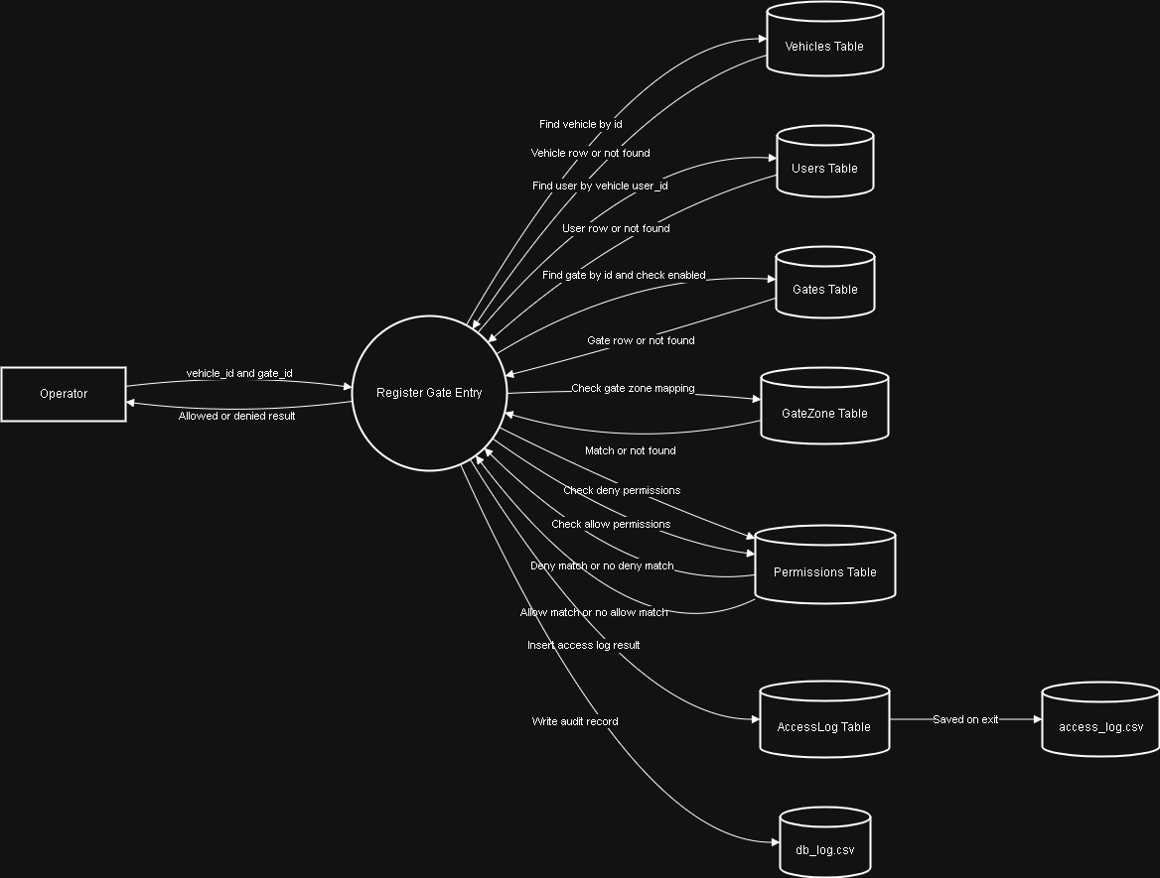

Flowcharts

Flowcharts were utilized in describing the system in procedural terms, as well as to supplement the data-oriented perspective of the DFDs.
Overall System Flowchart

The general system flowchart explains the program execution process starting to the end. It starts with the preparation of the system, loading CSV data into memory, and the creation of hash indexes. This system will then go into a menu based loop whereby the user will select tables and operations.
Validation, execution, updating of index, and logging is done before going back to the menu in each operation. On exit, all data in memory is stored back to CSV files. This flowchart gives a good picture of the system lifecycle and operation sequence.

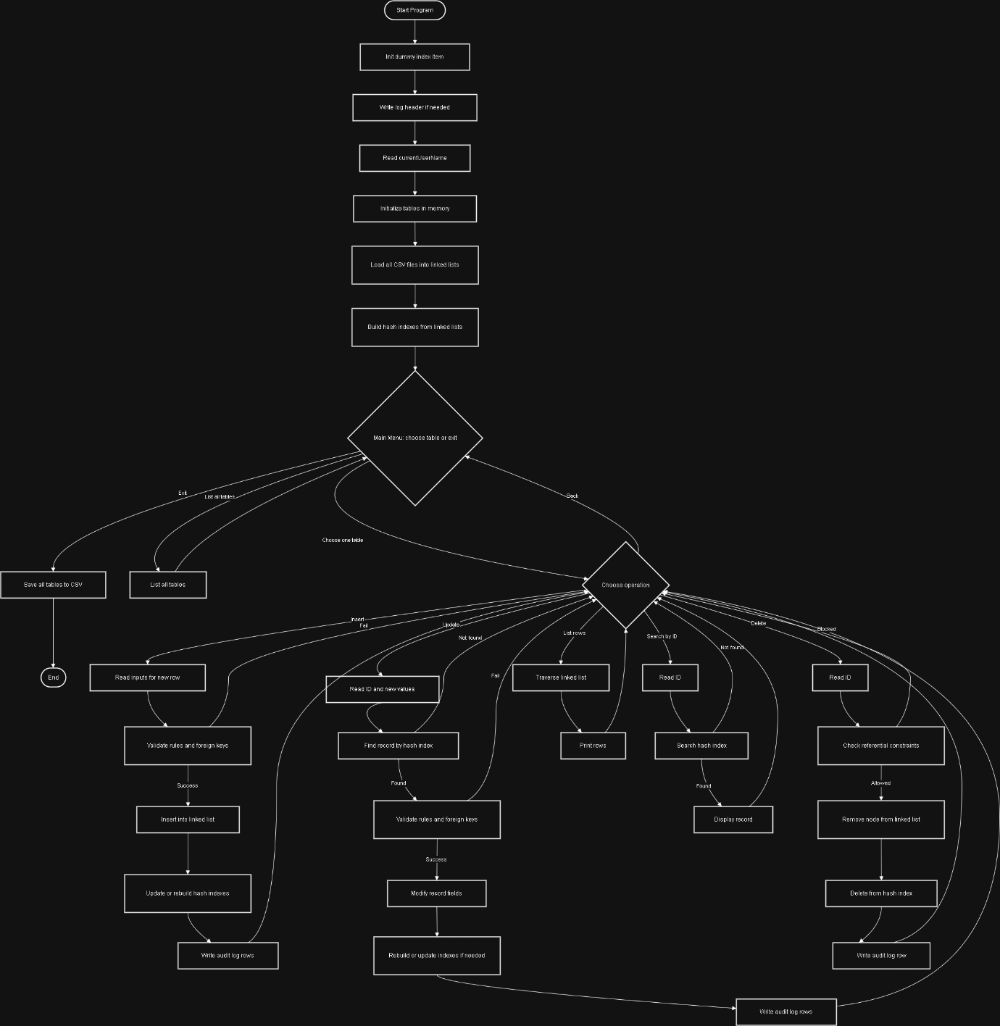

Gate Entry Flowchart

The logic of decision-making to grant or deny entry is described in the gate entry flowchart. It displays the sequential authentication of vehicle presence, user affiliation, gate position, zone allocation and permission regulations.
The flowchart also shows clearly how deny rules predominate over allow rules and the recording of every decision in the access log. Such a representation assists in the explanation of the control flow and logic of one of the most significant system operations.
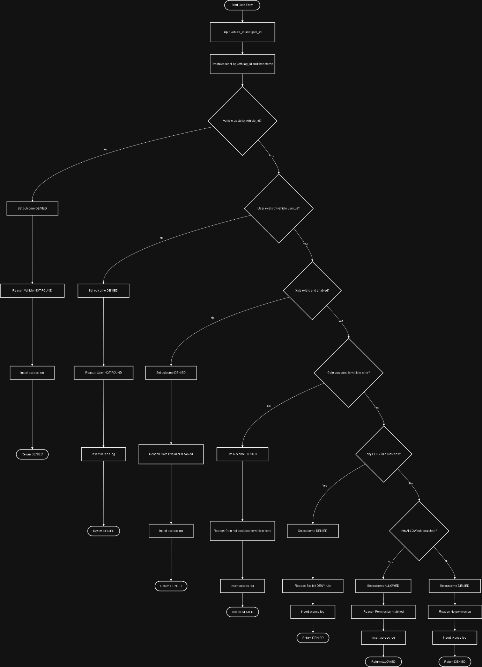

Conclusion

The Data Flow Diagrams and flowcharts together illustrate data movement in addition to control flow in the DBMS. The DFDs are concerned with the movement of data between the system components whereas the flowcharts are a description of how the system will work step by step This combination provides a clear and comprehensive view of the internal workings of the DBMS.

Evaluation of data transfer

The capability of the DBMS to move the data between its elements was assessed based on accuracy, effectiveness, uniformity, and data flow clearness. The analysis is based on the flow of data between the user interface and the internal processing layers and ultimately, to persistent storage, and the interaction of the intermediate components with one another.

Data Transfer Between User Interface and Application Logic
The communication between the user interface and the system logic is done via a command-line interface. The user inputs of the type of operations, identifiers, and attribute values are captured and validated and then sent to the core DBMS operations. This will help to make sure that only legitimate and properly structured data gets forwarded to the internal components and the chances of propagating wrong data will be minimized. The sequential interaction model ensures reliable and predictable data transfer at this point.

Data Transfer Within Internal DBMS Components

After validation, data is moved to the in-memory data layer where linked lists are used to store records, which are stored in the operations layer. This transfer is direct and effective, with records being represented in structured forms of data and passed by reference in the program.

The system stores key values in the indexing component which indexes them using hash-based indexing to support fast access. The indexing manager uses the primary keys to generate memory addresses of records in memory so that data may be easily retrieved without any repetition of data. This architecture is effective in internal data transfer as it keeps the redundancy to a minimum, and the access speed is enhanced.

Data Transfer Between Memory and Persistent Storage
The persistence of data is done in the form of CSV files, which serve as the external storage layer. When the system is started, the data is loaded into the in-memory tables in the CSV files, and all the records are ready to be processed. When the program is ended, the in-memory data will be updated and back-transferred to CSV files. This transparent distinction between memory and storage enables the movement of data which is controlled and reliable and which avoids the partial movement of data and ensures the consistency of the data.

Data Transfer for Logging and Auditing
The system has a special audit logging system to trace all the changes in data. Change details are sent to the audit logging component, and upon any insert, update, or delete operation, written to a log file. This mechanism also gives traceability and makes the movement of data not only practical, but also visible and verifiable. Also, the decision made in access control is captured in the access log, which shows uniformity in transfer of data regarding security-related events.

Evaluation of Data Transfer Effectiveness
Generally, the DBMS shows a high capability of transferring data among the components in a well-organized and regulated way. The adoption of well-defined layers makes sure that data flow has a logical move without unnecessary connectivity. The in-memory data structure, hash-based indexing and file-based persistence allow efficient data movement and still ensure clarity and correctness.

The system is however designed to be single user and in a sequential mode of execution. Consequently, there is no support of concurrency control mechanisms, thus restricting scalability in multi-user environments. Irrespective of this weakness, the proposed data transfer design is suitable to the proposed scope and it can meet the functional requirements of the DBMS.

Conclusion
The analysis shows that the DBMS can move data between its elements successfully, between the input of the user and internal processing, indexing, storage, and logging. The data transfer mechanisms are sound, effective and align to the design objectives of the system and as such, the architecture is appropriate to implement a lightweight file-based DBMS.

Effectiveness of the database and DBMS
Database design and the DBMS design were considered according to the capability to fulfill the user requirements and the system requirements.
From a user perspective, the DBMS offers easy and clear command-line interface that allows the user to carry out the necessary database operations, such as, insert, update, delete, search, and list. The menu-based design is used to navigate users to every operation and reduce the number of errors in input and enhance usability. The system also provides the functionality of access control to the gate, whereby the user can send a request to access the gate and be sent an explicit response (ALLOWED or DENIED) depending on the predetermined rules. Besides, access logs and audit logs are also available, which satisfies user needs of transparency and traceability.

The design of the DBMS is well-structured and effective from a system perspective. Linked lists are used to store data in memory and they are flexible and enable the management of records dynamically. The indexing is done by using hash-based indexing so that records can be accessed quickly by use of primary keys which enhances the system performance in terms of search and update operations. The use of CSV files helps in data persistence and therefore the data is stored between the runs of the program. The distinct separation of in-memory processing, indexing, persistence and logging is evidence of a well structured system architecture.

Altogether, the database and DBMS design are suitable with respect to the user and system requirements identified. The system provides the necessary functionality, reasonable performance, and a simple, yet structured internal structure, which makes it appropriate as a lightweight file-based database management system with the scope of the project.

DBMS Development

SQL Queries

The DBMS put in place is a file-based system that was written in C programming language and is not based on a native SQL engine. Rather, the SQL functionality is modeled using command-line operations and respective C functions. The SQL statements provided are all translated into a given function and implemented on in-memory tables, maintaining all the SQL constraints, including primary key uniqueness, referential integrity, and controlled deletion. Due to the use of CSV files, persistent storage is possible.

The DBMS has the following relations:
Organization, Role, Users, Zone, Gate, GateZone, Vehicle, Permission, AccessLog, as well as an audit log file (dblog.csv).

INSERT Queries
The DBMS provides SQL-equivalent INSERT operations for all tables. The implementation of each insert operation is done using a specific function (insertuser, insertvehicle, insertpermission) and is activated by the menu-driven interface.
SQL Behaviour Emulated
- Primary Key Constraint:
Every time there is an insert operation, the primary key is checked to ensure that there is no existing primary key. In case of a duplicate primary key detected the insertion is rejected, as with SQL PRIMARY KEY constraints.
- Foreign Key Constraint:
Referential integrity is imposed manually. Referenced entities are verified before they can be inserted to make sure that they are not nonexistent. For example:

  - The users need valid Organization and Role identifiers.
  - Users and Zone identifiers in vehicles are required.
  - The GateZone entries must have the valid Gate and Zone identifiers.
  - Permission entries confirm the existence of gates and make sure that targets of roles or vehicles exist.

- Domain Constraints:
Some types of fields are constrained to set values (e.g. permission actions are restricted to allow or deny), like SQL CHECK constraints.
Primary Key Auto-Increment
Primary keys are automatically created to model SQL AUTO_INCREMENT behaviour. The tables have a nextid attribute that holds the next available primary key. When it is inserted, this counter is used to assign the primary key and it is increased. When starting up the system, scanning of existing CSV records is done and nextid is set to one higher than the highest existing identifier ensuring continuity and uniqueness across executions.

SELECT Queries
The DBMS allows SQL-like SELECT operations in two types:
SELECT by Primary Key
Equivalent to:
SELECT * FROM table WHERE primary_key =
This is done through hash-based indexing which enables one to retrieve a single record with its primary key quickly. If the record is not located, the operation yields no result, just as SQL does.

SELECT All Records
Equivalent to:
SELECT * FROM table;
This process repeats itself through the linked list that represents the table and gives out all the records that are stored.

UPDATE Queries
All tables have SQL-equivalent UPDATE operations which are expressed in terms of specific update functions.
SQL Behaviour Emulated
- Updates are implemented in the case of the presence of the target record.
- Any new values of foreign keys are re-validated to maintain referential integrity.
- The constraints (in GateZone) are the composite key constraints, which are imposed to eliminate duplication following updates.
Once an update has been successful, the indexes are rebuilt to ensure consistency and the update is logged in the audit log.

DELETE Queries
Strict referential integrity rules are used to implement SQL-equivalent DELETE operations.
SQL Behaviour Emulated
- In case there is no record, then the delete operation is irrelevant.
- There is a limit to deletion when the record is referenced by a different table, which is like the default ON DELETE RESTRICT of SQL.

Examples include:
- organizations cannot be deleted if referenced by users.
- Users may not be deleted when they are mentioned by Vehicles or Access Logs.
- Gates are impossible to delete when they are mentioned in GateZone, Permission and Access Log entries.
Successful deletions get the record out of the linked list and the corresponding index and are logged in the audit log.

Additional SQL-Like Features Implemented
Indexing
Primary keys of all the tables are indexed using hash. This is like SQL indexes and enhances greatly the speed of search, update and delete operations.

Audit Logging
Any insert, update or delete operations leave audit records on dblog.csv. The conceptual understanding of this behaviour is much like SQL triggers that document changes in data to be audited and traced.

Stored-Procedure-Like Operation
The gate entry operation is a database operation which is performed in multi steps where a series of record lookups are made, access control rules are evaluated, and an access log record is inserted. This operation is like a stored procedure that can contain business logic in the database layer.

Conclusion
The implemented DBMS successfully emulates core SQL query functionality, including INSERT, SELECT, UPDATE, and DELETE, while enforcing primary key uniqueness, foreign key validation, restricted deletions, and automatic key generation. The CRUD operations behave consistently with standard SQL semantics, fulfilling the requirement that database operations act like their original SQL counterparts.

Data structures
Dynamic Data Structures of the Buffer and Storage Managers.
DBMS is carried out with dynamically allocated data structures to efficiently handle memory and accommodate variable sized datasets in the run time. The database records are dynamically allocated with the help of a heap allocation to all memory, which is flexible and scalable.
All the database relations (Organization, Role, Users, Zone, Gate, GateZone, Vehicle, Permission, and AccessLog) are stored in memory as a singly linked list. All the records are maintained in a dynamically allocated node structure in which case every insertion activity allocates new memory by means of malloc and the deletion activities explicitly release the memory by free. This design enables the system to expand or contract without set boundaries meeting the dynamic memory allocation requirement.
To facilitate effective access and minimize the time on a look up, a buffer-like indexing system is deployed with hash-based index arrays. Every index record holds a dynamically allocated structure that holds the primary key and a pointer to the correlative record in the linked list. These index structures are also assigned dynamically and rebuilt as the dataset changes to maintain consistency.

This separation between:
- the storage of records (linked lists)
- the buffered access paths (indexes based on hash)
is like logical functions of a storage manager and a buffer manager in the conventional DBMS architectures.
Storage Manager Implementation.
The storage manager will oversee persistent storage of data and recovery of data during program executions. Given that the system is a file-based system and does not use a native DBMS engine, persistence is implemented through CSV files.
Data Saving (Data Persistence)
Tables are represented by a specific CSV file that is used as their persistent storage. The in-memory linked lists are modified when the program is running, all the operations (INSERT, UPDATE, and DELETE). The storage manager saves the current state of each table to its respective CSV file before termination of the program and uses table specific write functions.
Each write operation:
- Overwrites the CSV file
- Writes a header row
- Serializes all records in memory to a CSV row.
This ensures that the current state of the database is always the current committed data.
Data loading
The storage manager reads all the data that has been saved earlier in the CSV files and loads them into memory at the initial stages of program execution. Each table has a read function:
- Opens the respective CSV file.
- Skips the header row
- Automatically allocates memory to each record.
- Rebuilds the linked list memory.
During loading, the system also re-computes the following available primary key value by following the highest current identifier. This makes new records inserted by the system keep primary key sequencing on track, just like SQL AUTO-INCREMENT would do even when executed more than once.
Once all tables are loaded, rebuilding of the hash-based indexes is done whereby the fast lookup operations are instant.

Indexing

The implemented indexing technique is a hash-based primary-key index built in C to speed up the simulated SQL operations (especially SELECT ... WHERE PK = ?, and the “find-then-update/delete” pattern). The design follows a classic DBMS idea: records are stored in one structure (linked list), and access paths (indexes) are stored separately to avoid scanning the list every time.
Why indexing was needed in this DBMS
All table rows are stored in memory as singly linked lists (OrganizationNode, UserNode, etc.).
Without indexing, any “SQL-like” query such as:
- SELECT * FROM Users WHERE user_id = 25
- UPDATE Gate SET enabled=0 WHERE gate_id=2
- DELETE FROM Vehicle WHERE vehicle_id=10
would require a full linear scan from the head node until the record is found.
To optimize this, hash indexes so that primary-key lookups become near constant time.

Index structures implemented in the code
Index item (what is stored in an index slot)
Each index entry stores:
- key: the table’s primary key value
- ptr: a pointer directly to the record in memory
This is the main performance optimization: the record is reached immediately by pointer, instead of scanning nodes.

One index per table
The DBMS maintains a separate hash array for each table
So each table can have fast access by its key.

Hash function (mapping key → array slot)
- Converts a primary key into a bucket index in range [0..INDEX_SIZE-1].
- INDEX_SIZE = 1013 (a prime) helps distribute keys more evenly and reduces collisions.

Collision handling technique: linear probing (open addressing)
When two keys hash to the same slot, the code uses linear probing:
- Insert logic
Meaning:
- If the hashed slot is occupied, move to the next slot.
- Keep moving until an empty slot (NULL) or deleted slot (key == -1) is found.
- Search logic
Meaning:
- Start at hashed slot.
- Scan forward while not NULL.
- Stop if key found, else continue probing.
This makes average lookups very fast, unless the table is heavily loaded.

Deletion support: dummy item (tombstone)
Open addressing has a known issue: you cannot simply set a deleted slot to NULL, because that would break searches for keys that were inserted later in the probe chain. The code solves this using a dummy tombstone:
Deletion marks a slot as “previously occupied”:
These preserves correct probing behavior.

Composite-key indexing technique: GateZone table
GateZone has a composite key logically: (ZoneID, gate_id).
Since the hash index uses an int key, the code converts the composite key into one unique integer:
Then indexing and searching become consistent
This is how the DBMS simulates an SQL composite primary key index efficiently.

How indexing integrates with the simulated SQL queries
SELECT by primary key
Each find_*_by_id() is implemented using the index, not list traversal:
So the SQL-equivalent query:
SELECT * FROM Users WHERE user_id = ?
is executed as a fast hash lookup.

INSERT behavior and indexing
Insert functions enforce SQL-like constraints first (PK uniqueness and FK existence).
Then they insert into both:
- linked list storage (add_*)
- hash index (indexInsert)
This ensures newly inserted rows become immediately searchable through the index.

UPDATE behavior and indexing
Updates are applied directly to the record returned by the indexed lookup:
Since the pointer points to the real row stored in the node (&node->data), the update modifies the in-memory row immediately.
after operations through the menu. This ensures indexes stay consistent across the whole DBMS state.

DELETE behavior and indexing
Delete functions remove:
- the node from the linked list
- the key from the hash index using indexDelete
This keeps search results correct after deletion.

Index rebuilding strategy
The function build_all_indexes() is used to rebuild every index from the current in-memory tables:
This guarantees:
- after loading from CSV
- and after any modification sequence
the indexes reflect the exact current state of the linked lists.

Performance impact on simulated SQL operations
Based on what the code implements:
- Search-by-ID (SELECT ... WHERE PK) becomes near O(1) average due to hash index.
- Update-by-ID and Delete-by-ID also become near O(1) average because they begin with indexed lookup.
- List all rows (SELECT *) remains O(n), because it intentionally traverses the linked list to print every row.
- FK checks (verifying OrgID, role_id, user_id) become efficient because FK existence checks call find_*_by_id() which is also indexed.

Criticizing the mapping of SQL queries

The designed DBMS translates SQL statements (INSERT, SELECT, UPDATE, and DELETE) into C-based CRUD functions that use in-memory linked lists with hash-based indexes and data persisted using CSV files. The mapping has been able to model key SQL semantics including primary key uniqueness, foreign key validation, restricted deletions and efficient access using the primary key. A few of the limitations however are visible when compared to a real SQL engine both in functionality and optimization. These limitations are assessed in the following critique and suggestions given to improve the effectiveness and realism of the simulated SQL behaviour.

Limitations of the Current SQL-to-CRUD Mapping
To begin with, SQL queries are not handled as textual statements. Rather, it is performed by a menu-driven interface that calls CRUD functions directly. This makes the system unable to really do SQL parsing and unable to do flexible query syntax, conditional expressions, joins, ordering, grouping, and projections. Although the underlying behaviour is like SQL, the interaction model is a function-oriented model as opposed to a query-oriented one.

Second, the UPDATE and the DELETE operations are mostly restricted to the execution based on the primary key. Unlike SQL, which allows set-based operations that act on several rows with conditional WHERE clauses, the current implementation only allows single row updates and deletions based on their primary key. This limits the expressiveness of the simulated SQL layer.

Third, index maintenance is done through full rebuild strategy. Once data is modified, all the indexes are cleared and recreated using the linked lists. This is correct, but not efficient as real SQL engines only update the index entries which were changed. This model also introduces unwarranted overhead as the volume of data grows.

Fourth, despite the optimization of primary key access with the help of hash indexes, certain operations are based on linear scans. Referential integrity checks on deletes, and any other access based on non-primary-key attributes, involve traversing complete linked lists. Foreign key or secondary indexes are usually optimized in SQL systems to carry out such checks.

Fifth, the persistence model is non-transferential. Information is stored on CSV files without atomic commits, rollbacks or crash recovery. In case the program fails suddenly when trying to write something, the data integrity can be destroyed. This is contrary to SQL databases whereby transactional functions provide atomicity and durability.

Sixth, input processing and data validation is restricted as compared to SQL engines. Basic string scanning is used to read input, and it does not completely support spaces, formatting validation, and special characters. csv parsing also presupposes the presence of well-structured data that can cause inconsistencies in the case of invalid data input.

Lastly, the compound key management applied in the GateZone table is based on arithmetic key construction. It is a method that assumes constraints on the value of the identifiers are fixed and will collide in case the assumptions are breached. Composite primary keys are not constrained in SQL.

Suggested Improvements to Optimize the CRUD Mapping
The first area would be to use incremental index maintenance instead of full index rebuild strategy. Only affected records should be updated with indexes during INSERT, UPDATE, and DELETE operations, and this will bring the behaviour of the indexes closer to the SQL indexing mechanisms and make them much faster.

Adding secondary indexes on the foreign key attributes would also optimize the referential integrity checks and permission validation. This would avoid complete scanning of tables when doing delete operations and enhance efficiency of the queries in general.

It would be better to extend the CRUD functionality to conditional operations to make SQL more realistic. Simple WHERE support would be more consistent with the set-based processing model of SQL and would support more expressive queries by supporting simple WHERE conditions on attributes that are not the key.

The key management of composite key can be enhanced by incorporating safer methods in the construction of keys that do not depend on the presumed limits of the identifiers. This would guarantee accuracy and scalability with increase in data.

Transaction safe file writing would help to enhance the persistence layer. To minimize chances of corruption, it would be better to write to temporary files and replace original CSV files and this would mimic SQL durability guarantees.

Lastly, the input validation and CSV parsing would be better to improve data integrity. Better input processing and validation would minimize the possibility of invalid records into the system.

Conclusion
The developed CRUD mapping manages to replicate the core SQL behaviour of operations based on the primary key and shows good utilization of indexing to enhance performance. Nonetheless, query expressiveness, index maintenance efficiency, referential integrity optimization, transactional safety, and composite key are still limited. With incremental updates on indexes, addition of secondary indexes, conditional query support, enhanced persistence and enhanced validation, the CRUD layer can be further refined to be more like the behaviour and robustness of a physical SQL database engine without violating the system file-based structure.

Concurrency Control (CC)

Standard DBMS CC Techniques
The concurrency control of a DBMS is the one that manages the accessibility of shared information by several transactions at the same time and maintains the correctness and consistency of the database. The main goal of concurrency control is to have the same outcome of concurrent execution of transactions as some serial execution and still achieve parallelism to enhance performance.

The concurrency control methods of standard DBMS are aimed at avoiding the typical concurrency issues of lost updates, dirty read, unrepeatable read, and analysis inconsistency.
- Lock-Based Concurrency Control.
The most common method of concurrency control in DBMSs is locking and the fundamental method taught in the slides.
- Shared (S) Lock
  - Read-only operations (e.g., SELECT).
  - There can be several transactions that have an S lock on the same data item simultaneously.
  - Ensures that the data that is being read is not altered during the time the read is being done.
- Exclusive (X) Lock
  - Write (INSERT, UPDATE, DELETE).
  - An X lock can only exist on one transaction on a data item.
  - Blocks any other read or write operations on the same data.
- Lock Compatibility
  - S + S - allowed
  - S + X - not allowed
  - X + X - not allowed
This provides write isolation and read consistency.
- Two-Phase Locking (2PL)
Two-Phase Locking is a typical correctness protocol, which is based on locks.
It separates the execution of transactions into two processes:
- Growing Phase
  - Locks may be obtained over transactions.
  - There are no locks set free with this stage.
- Shrinking Phase
  - Lock may be released by transaction.
  - There is no possibility of obtaining any new lock after initial release.
This protocol ensures conflict serializability, i.e. the concurrent schedule is the same as a serial schedule.
- Variants
  - Strict 2PL: X locks are held until transaction commit or abort.
  - Rigorous 2PL: Both S and X locks are held until commit.

- Blocking and Waiting Mechanism
In case a transaction seeks a lock but it conflicts with an existing lock:
- Immediacy of the transaction is not possible.
- It is put under a state of waiting until the lock is available.
This is shown using a straightforward logic in the slides:
- If lock exists transaction waits.
- If no conflicting lock transaction proceeds.
This mechanism eliminates unsafe interleaving but can cause waiting chains.
- Deadlock in Lock-Based CC
Deadlock Definition
A deadlock occurs when: Two or more transactions are waiting interminably to have locks taken by each other.
Example
- T1 puts X lock on A and waits on B.
- T2 is holding X lock on B and waiting on A.
Standard DBMS Handling
- Wait-for graph-based deadlock detection.
- Prevention of deadlock with timeouts or ordering.
- Deadlock recovery through the abort of a transaction.

- Timestamp-Based Concurrency Control.
In timestamp ordering, transactions are given unique timestamps as they begin.
Key Idea
- Operation should be done in time sequence.
- In case an operation is in violation of the order, the transaction is rolled back.
Characteristics
- No locks are used.
- Eschews deadlocks entirely.
- May result in increased rates of abortion in times of great competition.
It is an orientated method that focuses more on logical sequences and not mutual exclusion.
- Optimistic Concurrent Control (OCC)
Optimistic CC assumes that:
- Conflicts are rare.
- The transactions are executed without locks first.
Phases
- Read Phase: The transaction is carried out as usual.
- Validation Phase: Before commit checks.
- Write Phase: When validation is successful, changes are implemented.
Advantages
- In low-conflict settings, high concurrency is observed
- No blocking on the execution.
Disadvantages
- Expensive rollbacks in case of frequent conflicts.

- Granularity of Locking
The locks may be done at various levels:
- Database-level
- Table-level
- Page-level
- Row-level
Trade-off
- Rough-cut locks - less complex but less concurrent.
- Fine-grained locks - increased concurrency and increased overhead.
The slides focus on table-level locking as an easy and straightforward instructional model.
Summary
Concurrency control methods of the Standard DBMS are meant to achieve:
Maintain data consistency
Safe parallel execution.
Avoid concurrency anomalies.
The most widely used and conceptually highlighted technique is lock-based concurrency control that uses Shared and Exclusive locks along with Two-Phase Locking. Different trade-offs are offered by other methods like timestamp ordering and optimistic concurrency control.

Implementation of CC

Parallel Data Processing and Concurrency Control.
The developed DBMS had parallel data processing achieved by modelling an approach of simulating parallel database processing using multithreading and lock-based concurrency control mechanism. This was to enable several users to make database operations simultaneously and maintain the data consistency and correctness as demanded in a standard DBMS environment.

Parallel Processing with Threads.
The DBMS relies on POSIX threads (pthreads), to emulate numerous users at the same time. The concurrency control test is performed by each user request in a different thread. This allows running of multiple database activities simultaneously which is very similar to real DBMS systems where transactions run in parallel.
The threads are user transactions, and they execute a single database operation (SELECT, INSERT, UPDATE or DELETE) on a chosen table. The threads are created nearly at the same time and can execute simultaneously and reveal potential conflicts on shared data.

Lock Based Concurrency Control.
The implementation of concurrency control is based on lock-based techniques, which are the main ones that are discussed in the slides. The logical lock structure secures each table in the database to access by concurrent threads.

Two lock modes are supported:
- Shared (S) Lock
Read Only: SELECT. Shared locks on a single table can have multiple threads running on them simultaneously.

- Exclusive (X) Lock
Write operations, including INSERT, UPDATE and DELETE. A thread can be locked exclusively on a table, and it prevents any other read or write operation to be performed on the same table.

A thread requests the correct lock depending on the type of operation before it performs any database operation. When the lock is compatible with existing locks, then it is granted instantly. Otherwise, the thread gets into a waiting state.

Waiting and Blocking Mechanism.
A thread that has a conflict with the required lock does not continue with an execution. Rather, it keeps on waiting until the lock is free. In this period, a definite message like wait is printed and therefore the concurrency behaviour is visible.
This is a direct implementation of the blocking and waiting logic that was introduced in the lecture slides where transactions wait until conflicting locks are released.

Execution and Lock Release
When a thread manages to obtain its lock, it performs the database operation on the in-memory structures that are shared. Once the operation is complete, the lock is released, and the threads that are waiting can resume executing.
This is in accordance to Two-Phase Locking (2PL):
- Access to data is obtained by acquiring locks.
- The locks are not unlocked until after an operation is completed.

Integration with Existing DBMS Operations
The concurrency control mechanism is incorporated to the existing CRUD functions of the DBMS. The database structures, validation rules, and constraints are the same during normal execution as those used in all the operations that were performed during the concurrency test. This makes sure that primary key constraints, foreign key checks and referential integrity are respected.

Once all threads have completed their execution, rebuilding of indexes is done to ensure consistency between the in-memory data and the indexing structures.
Summary
The developed DBMS uses the concurrency control lock-based with multithreading to parallelize data processing. Threads are used to simulate multiple users and shared and exclusive locks are used to provide safe access to shared tables. Blocking and waiting mechanisms eliminate the possibility of conflicting operations running in parallel and maintain the consistency of the database. This implementation illustrates a realistic practice of standard concurrency control concepts of DBMS with a simplified, educative model correlated with the course slides.

User Interface and Testing Plan

User Interface Development

Overview of the Interface
The DBMS created applies a menu-based, console interface. This interface was deliberately made straightforward, concise and completely in line with the course objectives and laboratory content. It enables users to interface with all DBMS functions using structured text menus and does not need any external GUI libraries.
Although it is text-based, the interface supports full coverage of database operations, such as CRUD operation, search, listing, logging and testing concurrency control.

Session Initialization
Once the program is launched, the user is asked to input his name to commence a session.
This name is logged and is used subsequently in the logging system to trace the user who made each database operation.
Then, all the database tables are loaded automatically by CSV files, which guarantees the data persistence across the runs.

Main Menu (Table Selection)
After the initiation, a main menu is offered to the user that contains all the tables in the database and system options:
- Organizations
- Roles
- Users
- Zones
- Gates
- GateZone
- Vehicles
- Permissions
- Access Logs
- List All Tables
- Concurrency Control Test
- Exit
To choose a table, the user enters the relevant number of the table. This design is easy to navigate and valid operations are prevented.
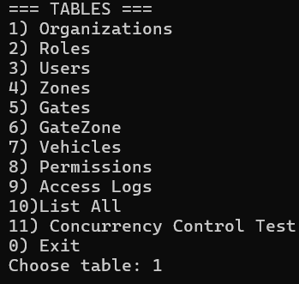
Operations Menu (CRUD Functionalities)
A specific operations menu is presented on each table that is selected. The following operations can be performed depending on the type of table:
- insert: Add a record with full validation.
- Update: Modify existing records but with constraints.
- Delete: Delete records, which have referential integrity checks.
- Search by ID: Get a particular record based on its primary key.
- Show all rows: Show all the records of the chosen table.
- Back : return the user to the main menu
The user must input each attribute required in each operation, minimizing errors in inputting the required attributes and enhancing usability.
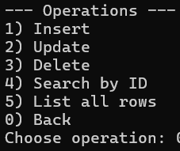
Concurrency Control Interface Test.
Special Concurrency Control Test mode is also included in the interface which can be accessed by the main menu.
In this mode:
The user defines the number of simulated concurrent users (threads).
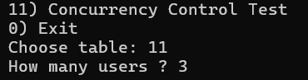
Each simulated user selects:
A table
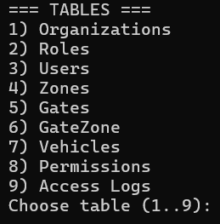
A query (SELECT, INSERT, UPDATE, DELETE)
The system then starts all threads concurrently.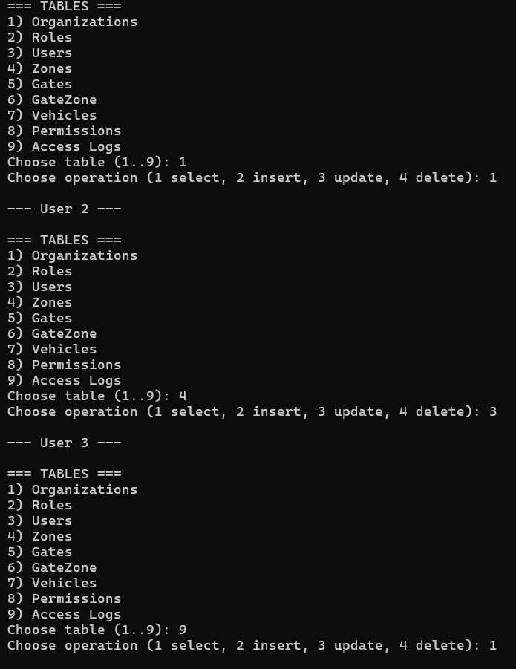
During execution, the interface clearly displays concurrency behaviour, such as:
- Lock acquisition (Shared or Exclusive)
- Waiting due to lock conflicts
- Lock release after operation completion
This makes concurrency effects visible and easy to understand, which is particularly useful for educational demonstration and testing.
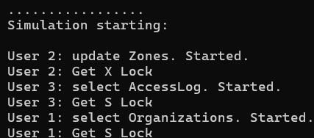
Output and Feedback
The interface gives real-time textual response to all actions, such as:
Validation errors
Foreign key constrain violations.
Blocking messages through references.
Lock messages and concurrency waiting.
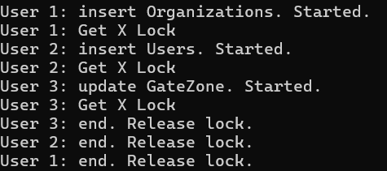
This feedback makes it transparent and allows the users to know the internal DBMS behaviour.
Usability and Design Rationale.
- The interface has a uniform design in all the tables.
- All menus are numbered and well-marked.
- Defaulting to valid ranges is the safe way of handling invalid inputs.
- It is designed to be simple and easy to read, which is why it is suitable to students and evaluators.
The interface is a console-based interface, but it is a full DBMS control panel, just like administrative command line tools in real database systems.

Summary
The created user interface is a menu based structured user interface which is a complete support of all DBMS features. It allows users to operate database tables, CRUD operations, concurrency testing, and real-time system behaviour. It has a simple, rational and functional interface, and it is both functional and educational, which corresponds to the demands of the assignment and course labs.

Testing Plan

Testing Objective
The purpose of this testing plan is to ensure that all developed DBMS components function correctly and integrate properly with each other. The tests verify:
- Correct execution of CRUD operations for all tables
- Enforcement of primary key and foreign key constraints
- Correct behavior of delete-blocking due to referential integrity
- Correct operation of hash-based indexing
- Data persistence using CSV files
- Proper logging of database operations
- Correct handling of concurrent operations using concurrency control

Test Environment
- Programming Language: C
- Platform: Windows (Console Application)
- Storage Mechanism: CSV files
- Concurrency Model: Threads (pthreads)
- Logging Output: db_log.csv

Testing Strategy
The DBMS was tested using a layered testing strategy that covers all functional and non-functional components:
- Functional Testing (CRUD operations)
- Constraint and Validation Testing
- Indexing Testing
- Persistence Testing (CSV Load/Save)
- Logging Testing
- Concurrency Control Testing
Each test includes the test goal, execution steps, expected result, and actual observed output.

Functional Testing (CRUD Operations)
Insert Operation Test
Component Tested: Insert logic, linked list storage, index insertion
Expected Result:
The record is successfully inserted and becomes visible when listing or searching.
Actual Result:
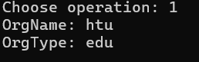
Update Operation Test
Component Tested: Update logic and index-based record access
Expected Result:
The record is updated correctly and changes appear when listed.
Actual Result:
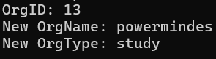
Delete Operation Test
Component Tested: Delete logic and index removal
Expected Result:
The record is deleted and cannot be found afterward.
Actual Result:
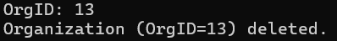
Search by ID Test
Component Tested: Hash index search
Expected Result:
The correct record is retrieved immediately.
Actual Result (Sample Output):
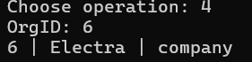
The same CRUD and constraint tests were repeated on Roles, Users, Vehicles, GateZone, and the remaining tables to ensure consistency across the entire database
Constraint and Validation Testing
Duplicate Primary Key Test
Component Tested: Primary key uniqueness enforcement
Expected Result:
Insertion is rejected.
Actual Result:
Foreign Key Violation Test
Component Tested: Foreign key validation
Expected Result:
Insertion is rejected.
Actual Result
Delete Blocked by Referential Integrity
Component Tested: Referential integrity enforcement
Expected Result:
Deletion is blocked.
Actual Result:
Indexing Tests
Index Consistency Test
Component Tested: Hash index rebuild
Expected Result:
Search works correctly before and after restarting.
Actual Result:
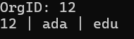
Persistence Testing (CSV Files)
Data Persistence Test
Component Tested: CSV read/write mechanism
Expected Result:
Previously inserted data is preserved.
Actual Result:
Saved to CSV files.
Loaded from CSV files.
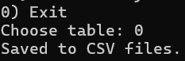
Logging Tests
Logging Insert Operation
Component Tested: Operation logging
Expected Result:
A new entry is added to db_log.csv.
Actual Result:
Concurrency Control Testing
Conflicting Operations on Same Table
Component Tested: Lock-based concurrency control
Expected Result:
The conflicting user waits until the lock is released.
Actual Result:
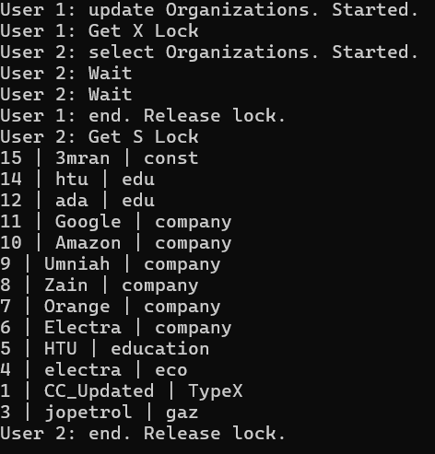
Non-Conflicting Operations on Different Tables
Expected Result:
No waiting occurs.
Actual Result (Sample Output):
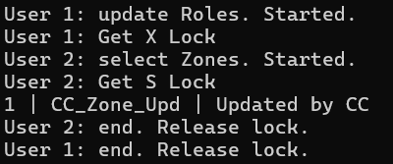

Compatibility Verification
The following compatibility checks were validated:
- CRUD operations remain consistent with indexing
- Data persists correctly between executions
- Logging accurately reflects database changes
- Concurrency control prevents conflicting operations
- Referential integrity is preserved even under concurrency

Test Results Evidence
Screenshots should be provided for:
- Successful CRUD operations
- Constraint violation messages
- Delete-blocking messages
- Concurrency waiting and lock behavior
- Log file entries

Summary
The testing plan confirms that the developed DBMS functions correctly across all components. Functional operations, constraints, indexing, persistence, logging, and concurrency control were all tested successfully. The results demonstrate that the system is stable, consistent, and compliant with standard DBMS behavior.

Evaluation

Evaluation of the DBMS and Required Improvements
Even though the developed DBMS effectively achieves functional and educational goals of the course, this is a continuous process, without which the effectiveness, scaling, and strength of any database system could be under threat. The assessment below highlights areas that can be improved to make sure that the efficiency, correctness, and usability will be ensured in the long term.

Concurrency Control Enhancement.
The existing DBMS has a simple lock-based concurrency control by having Shared (S) and Exclusive (X) table-level locks. Although this method is right to avoid inconsistent operations and data consistency, it can be enhanced.

Recommended Improvements:
- Add deadlock detection or prevention techniques, e.g. timeouts or wait-for graph analysis, to prevent the infinity between transactions.
- Use finer-grained locking (row-level locking, rather than table-level locking) to achieve more concurrency and less unwarranted blocking.
- Implement concurrency control, not only in testing mode, but in the normal operation of the application, all CRUD functions are performed under lock protection.
These would make the system more parallel and more like the real DBMS behaviour.

Performance and Scalability Improvements
The data in the current system are stored in linked lists and indexed using hash fast retrieval. The design is suitable when dealing with small and medium datasets but might not be efficient with high amounts of data.

Recommended Improvements:
- Use alternate structures, like B-trees or balanced trees, that are more scalable than linked lists and are widely used in the indexing of real DBMS.
- optimize rebuilding of indexes, update the indexes after every operation rather than rebuilding them.
- Implement rudimentary query optimization methods, including reducing the amount of full table scans.
These modifications would contribute greatly to the performance when the database is increased.

Storage Reliability and Persistence.
The DBMS is presently using CSV files in data persistence which is easy and transparent but lacks reliability and efficiency.

Recommended Improvements:
- Instead of using CSV storage, use a binary file format to enhance the speed of reading/writing as well as minimize the overhead of parsing.
- Use transaction logging (write-ahead logging) to ensure that the data is not corrupted in case of unforeseen system failure.
- Add automatic backup and recovery to make the information safe.
These would help to increase durability and fault tolerance.

Security and Access Control
Currently, the DBMS lacks user authentication and role-based access control, i. e., users have equal privileges.

Recommended Improvements:
- Implement user authentication and secure data storage.
- Use role-based authorization with various permissions to administrators, normal users, and read only users.
- Control sensitive operations like DELETE and UPDATE by user roles.
This would prevent unauthorized access to the database, and the accidental misuse.

Logging and Auditing Improvements
The logging system is successful in capturing any change in the database, and this comes in handy during auditing and debugging. Nonetheless, it may be extended to be more useful.

Recommended Improvements:
- Add querying and log filtering functions to simply monitor changes by table, user or time interval.
- Log rotation should be introduced to ensure that the log file is not continued growing.
- Insert transaction identifiers in the log records in order to merge the related operations.
These would increase traceability and maintainability.

Usability and Interface Improvements
The interface based on menu is understandable, uniform, and appropriate in education. Nevertheless, usability may be enhanced further.

Recommended Improvements:
- Introduce input validation and error recovery in a bid to deal with invalid user input in a more graceful manner.
- Show help menus or tooltips with an explanation of every operation.
- Optional creation of a graphical user interface (GUI) to interact with it easier and create a more user-friendly experience.
Such modifications would make the system user-friendly and professional.

Maintainability and Code Structure
The DBMS codebase is well-organized and modular, though it can never be made more maintainable.

Recommended Improvements:
- Split major components into independent source files (storage, indexing, concurrency control, logging).
- Enhance the documentation and inline comments of subsequent developers.
- add configuration files to configurable parameters including size of index and lock policy.
This would make it easier to develop and debug in future.

Summary
The developed DBMS is operationally accurate, stable and consistent with the standard DBMS concepts taught during the course. Future enhancements would aim at improving concurrency control, scalability, reliability of persistence, security, logging, usability, and maintainability to make it remain effective. These enhancements would make the system more realistic and stronger like a prototype of a database management system, as opposed to being just an educational prototype.

References
Database Systems SEVENTH EDITION. (n.d.). Available at: https://www.philadelphia.edu.jo/academics/ealmashagbah/uploads/Fundamental_of_Database_Systems-book.pdf.

Keesling, D., Kyte, T., McCormack, J., Adams, D., Agrawal, A., Anthony, T., Arora, V., Athraya, J., Austin, D., Baby, T., Barriere, V., Baer, H., Battula, S., Bayliss, N., Bednar, T., Beecher, V., Bolltoft, B., Bose, A., Brower, D. and Carpenter, L. (n.d.). Data Concurrency and Consistency. [online] Oracle Help Center. Available at: https://docs.oracle.com/en/database/oracle/oracle-database/19/cncpt/data-concurrency-and-consistency.html#GUID-4BD4DFD6-DAEA-41B2-BB56-7135568F0548.

‌
‌

